Requirement List of In-App Event for 2022 Korean New Year

내용

1. Requirement history 2

2. Requirements Purpose 3

3. Requirements List 3

# Requirement history

|  |  |  |  |  |
| --- | --- | --- | --- | --- |
| Version | Date | Author | Type | Contents |
| V1.0 | 2021-12-28 | Victoria | Pop-Up Notification (In-App Event) | 1. Mandatory pop-up notification after login 2. Enable phone number to be input at the pop-up notification (Limit one time per ID). 3. Enable coupon and text message to be sent instantly to mobile number entered. 4. Auto Remove the pop-up notification after event period |
|  |  |  |  |  |

# Requirements Purpose

The Main purpose of this logic is to enable customers to input phone number in pop-up notification and directly send the event coupon to the phone number input

# Requirements List

* + - 1. Mandatory pop-up notification for Korean customers after login during event period
      2. The pop-up notification can be turned off after customer tick the checkbox “turn off notifications”
      3. Add field in the pop-up notification to “Input mobile number” for customer to fill in phone number and “Send” button to send coupon and text message to the phone number
      4. When the customer enters mobile number and press “Send” button, coupon and event related text message will be sent directly to the mobile number
      5. Enable the customer to enter mobile number for one time only, and cannot send to the same mobile number more than once
      6. Auto Turn off the pop-up notification after event period (Tentative end date : 4February 2022)

**Mobile Application**

**Pop-up notification, Send Coupon (In-App Event):**

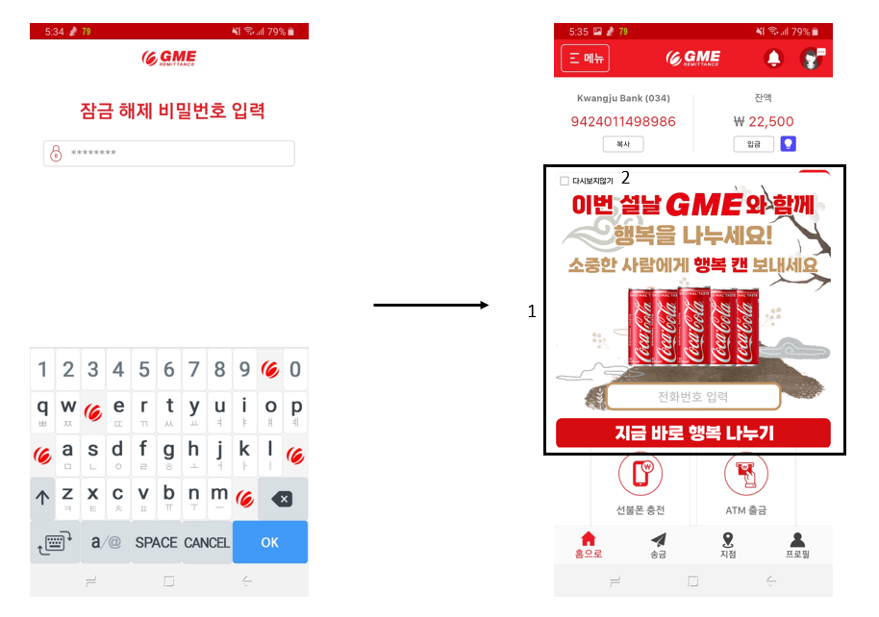

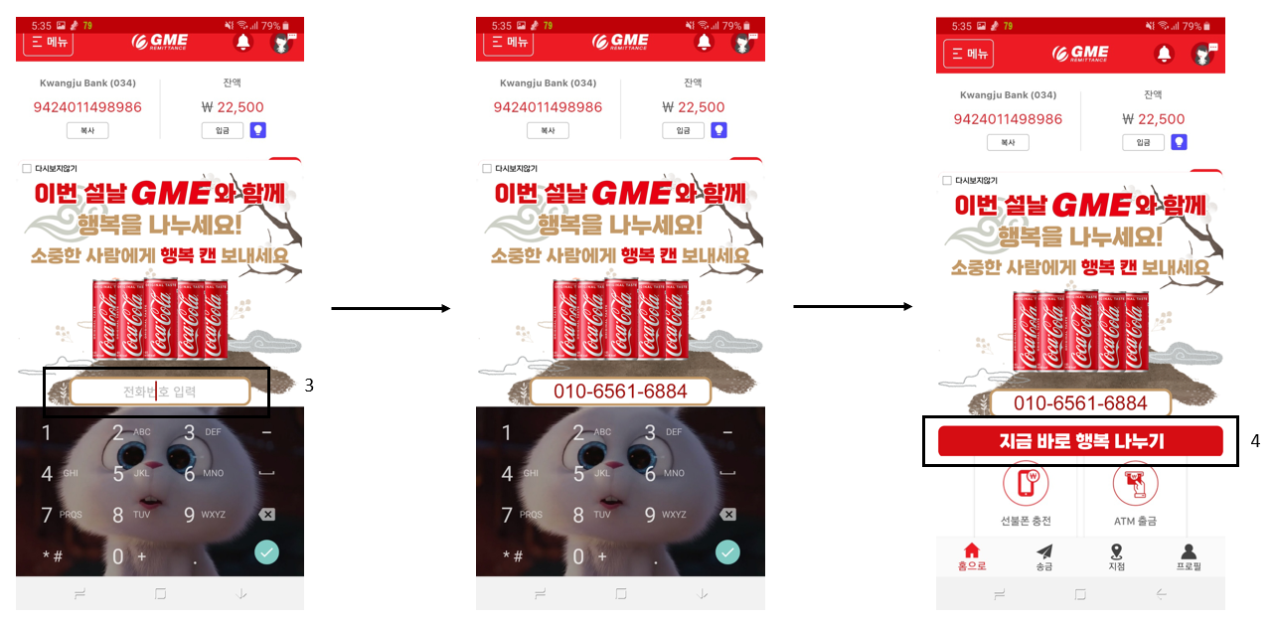

**\*Please make sure to add the command for the system to turn off the pop-up notification after event period\***

이벤트 기간 후에 팝업창 자동으로 꺼지는 기능 꼭 넣어 주시기 바랍니다

**5**

새해 복 많이 받으세요!

소중한 당신에게 행복을 보냈습니다~!

행복한 콜라 드시고 새해 복 많이 받으세요!

여러분도 소중한 사람에게 행복을 함께 나누어 보실래요?

GME해외송금 앱을 통해 함께 행복을 나누세요!

앱 링크 https://gmeremit.page.link/gmeremit

대한민국 1등 해외송금! 쉽고 빠르고 저렴하고 안전합니다!

**Flow Charts**

In-App Event (Send Coupon)

